5. Project Development Phase
Project: Implement Client Script & UI Policy (ServiceNow)

Phase Objective
In this phase, the planned functionality is implemented in ServiceNow. Configuration records, form fields, Client Script logic, UI Policy settings, and related actions are created or updated according to the requirements.

Activities Covered
- Create/update the required ServiceNow configurations.
- Implement Client Script/UI Policy behavior.
- Save and review the implemented settings.

Screenshots from the Project Video
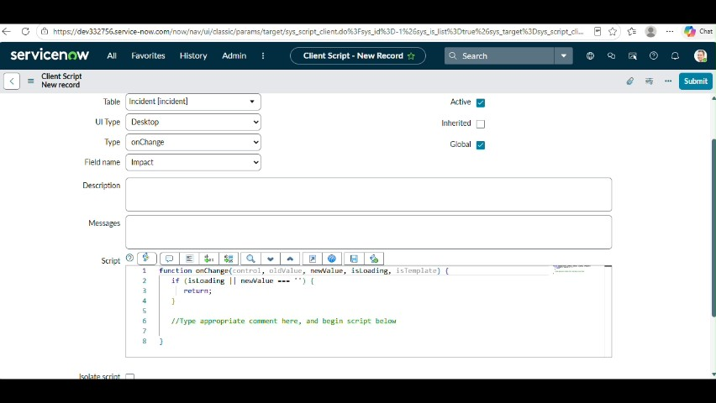
Figure 1: Project video screen at approximately 214 seconds.
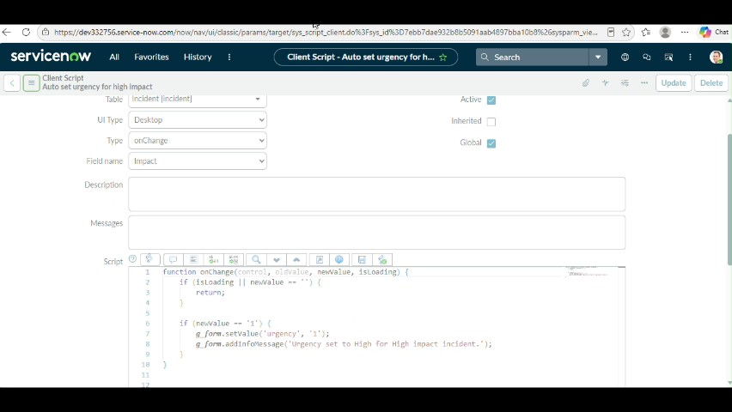
Figure 2: Project video screen at approximately 227 seconds.
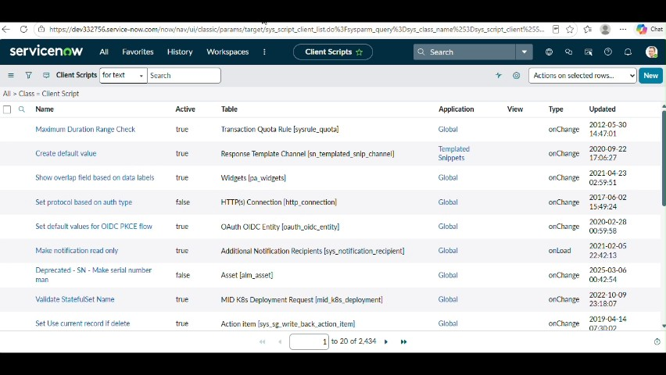
Figure 3: Project video screen at approximately 235 seconds.
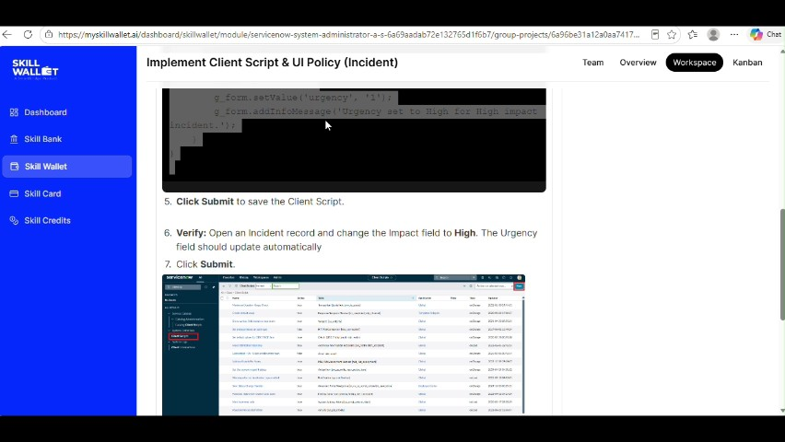
Figure 4: Project video screen at approximately 258 seconds.
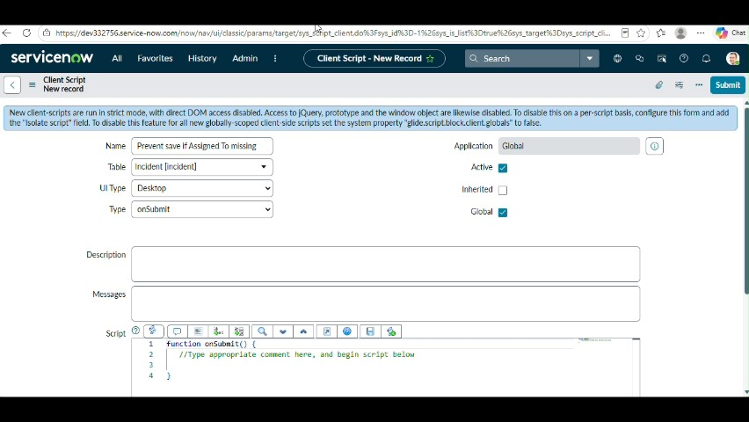
Figure 5: Project video screen at approximately 290 seconds.

Phase Outcome
The required functionality is implemented in the ServiceNow environment.
Prepared from the supplied project demonstration video

